./

GENESIS – ADVANCE-PYTHON

PROJECT REPORT

MEDICINE SERVICES THROUGH ATM



|  |  |  |  |  |  |
| --- | --- | --- | --- | --- | --- |
| **Ver. Rel. No.** | **Release Date** | **Prepared. By** | **Reviewed By** | **To be Approved** | **Remarks/Revision Details** |
| 1.0 | 12/12/2020 | Toti Shoba Rani |  |  |  |
|  |  |  |  |  |  |
|  |  |  |  |  |  |
|  |  |  |  |  |  |
|  |  |  |  |  |  |

**Details**

Contents

Contents 3

Activity 1 4

1.1 Source Code 4

1.2 Pep8Online: 6

Figure 1: Pep8 Online Snapshot 6

Activity 2 8

2.1 Code with OOPS concepts: 8

2.2 Pepe8 Online: 12

Figure 3: Pep8 Output Snapshot Using OOPS 13

3 Github link: 14

**4 REGULAR EXPRESSIONS…………………**……………………………………………………………………………………………….

**Table of Figures**

Figure 1: Pep8 Online Snapshot 6

Figure 2: pep8 Online Snapshot Using OOPS 7

# Activity 1

**Medicine Service Through ATM**

## **Source Code**:

|  |
| --- |
|  |
|  | print ("1.fever")  print (“2.cold”) |
|  | print ("3.stomachpain") |
|  | print ("4.legpain") |
|  | choice = input("enter the choice :") |
|  | if choice == '1': |
|  | print("1.medium") |
|  | print("2.high") |
|  | choice = input("enter the mode :") |
|  | if choice == '1': |
|  | choice = input(" enter the no of tablets u want :") |
|  | print("take paracetamol tablets") |
|  | else: |
|  | print("consult the doctor nearby atm") |
|  | if choice == '2': |
|  | print("1.Medium") |
|  | print("2.high") |
|  | choice = input("enter the mode:") |
|  | if choice == '1': |
|  | choice = input("enter the no of tablets u want :") |
|  | print("take crocin tablets") |
|  | else: |
|  | print("consult the doctor nearby atm") |
|  | if choice == '3': |
|  | print("1.Medium") |
|  | print("2.high") |
|  | choice = input("enter the mode:") |
|  | if choice == '1': |
|  | choice = input("enter the no of tablets u want :") |
|  | print("take Pantoprazole tablets") |
|  | else: |
|  | print("consult the doctor nearby atm") |
|  | if choice == '4': |
|  | print("1.Medium") |
|  | print("2.high") |
|  | choice = input("enter the mode:") |
|  | if choice == '1': |
|  | choice = input("enter the no of tablets u want :") |
|  | print("take Advin tablets") |
|  | else: |
|  | Print("consult the doctor nearby atm ") |
|  | else: |
|  | print(invalid) |

## **1.2 Pep8 Online:**

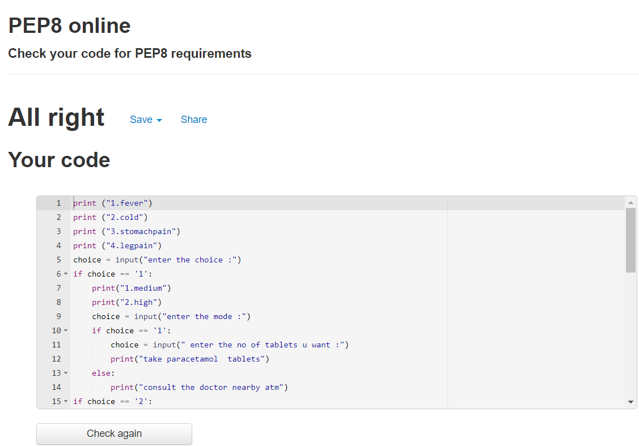

### Figure 1: Pep8 Online Snapshot

# Activity 2

## **2.1 Source Code with OOPS concepts**:

|  |
| --- |
|  |
|  | Class fever () :  def fever(self): |
|  | print("1 medium") |
|  | print("2 high") |
|  | self.choice = input("enter the mode:") |
|  | if(self.choice == '1'): |
|  | print("take paracetamol tablets") |
|  | self.choice1 = input("enter the no. of tablets u want:") |
|  | else: |
|  | print("consult the doctor near by atm") |
|  |  |
|  |  |
|  | class cold(fever): |
|  | def cold(self): |
|  | print("1 medium") |
|  | print("2 high") |
|  | self.choice = input("enter the mode:") |
|  | if(self.choice == '1'): |
|  | print("take crocin tablets") |
|  | self.choice1 = input("enter the no. of tablets u want:") |
|  | else: |
|  | print("consult the doctor near by atm") |
|  |  |
|  |  |
|  | class stomachpain(cold): |
|  | def stomachpain(self): |
|  | print("1 medium") |
|  | print("2 high") |
|  | self.choice = input("enter the mode:") |
|  | if(self.choice == '1'): |
|  | print("take Pantoprazole tablets") |
|  | self.choice1 = input("enter the no. of tablets u want:") |
|  |  |
|  | else: |
|  | print("consult the doctor near by atm") |
|  |  |
|  |  |
|  | class legpain(stomachpain): |
|  | def legpain(self): |
|  | print("1 medium") |
|  | print("2 high") |
|  | self.choice = input("enter the mode:") |
|  | if(self.choice == '1'): |
|  | print("take Advin tablets") |
|  | self.choice1 = input("enter the no. of tablets u want:") |
|  |  |
|  | else: |
|  | print("consult the doctor near by atm") |
|  | print("Welcome to our application") |
|  | print("1.fever") |
|  | print("2.cold") |
|  | print("3.stomachpain") |
|  | print("4.legpain") |
|  | obj = legpain() |
|  | ch = input("enter the choice") |
|  | if(ch == '1'): |
|  | obj.fever() |
|  | elif(ch == '2'): |
|  | obj.cold() |
|  | elif(ch == '3'): |
|  | obj.stomachpain() |
|  | elif(ch == '4'): |
|  | obj.legpain() |
|  | else: |
|  | print("Invalid") |
|  | print("Thanks for using our application\n visit again") |

## **2.2 Pepe8 Online:**

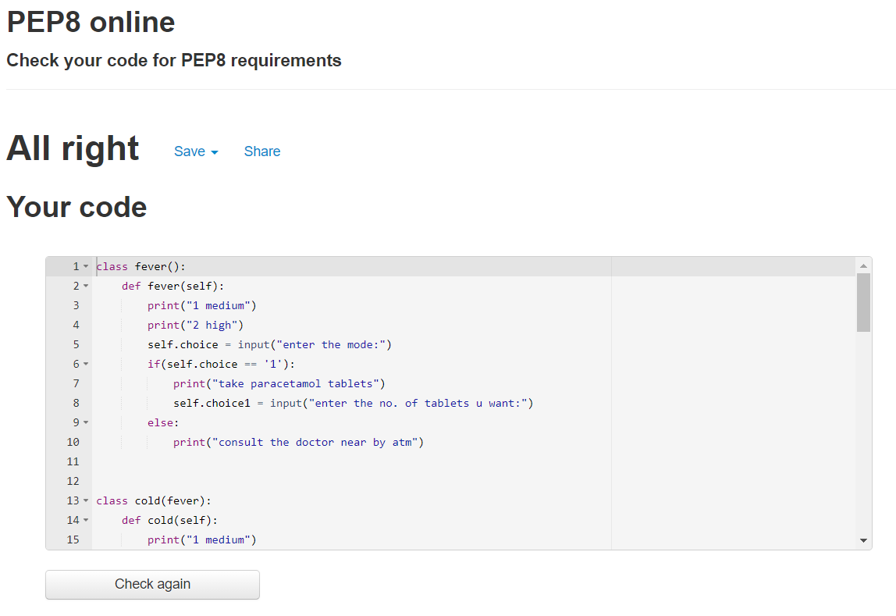

### Figure 3: Pep8 Output Snapshot Using OOPS

3. Github link:

<https://github.com/99003192/Medicine-services-through-atm>

Regular Expression :

|  |
| --- |
| import re |
|  | print("[a-z]+.[a-z]+@[a-z]+.[a-z]+", "toti.rani@ltts.com") |